A Project Report on

PLUGGING INTO THE FUTURE

AN EXPLORATION OF ELECTRICITY

CONSUMPTION

**A Student Performance Analysis .**

**by**

**ADARI ANUSHMA**

### Under the Guidance of

**Associate Professor**

**RAMACHANDRA COLLEGE OF ENGINEERING**

Approved by AICTE,New Delhi,NAAC Accreditation with A’ Grade,Accredited by NBA,NAAC & permanently affiliated to JNTU Kakinada.





ABSTRACT:

an ever-evolving world, the role of education in shaping the future has become increasingly vital ‘PLUGGING’ into the future:‘AN EXPLORATION OF ELECTRICITY CONSUMPTION’.

Preliminary findings indicate that academic success is not solely determined by conventional metrics such as standardized test scores, but rather, it is influenced by a combination of factors. These include a student's passion for learning, the support system they have at home and school, the relevance of the curriculum, and the presence of inspiring mentors and educators. Furthermore, this study delves into the significance of extracurricular activities and their impact on a student's holistic development. Participating in clubs, sports, arts, or community service can foster essential life skills, promote social interactions, and enhance self-confidence.

reviewing the mechanisms of drilling fluid lost circulation and its control in fractured formations, the applicability and working mechanisms of different kinds of lost circulation materials in plugging fractured formations have been summarized. Meanwhile, based on the types of lost circulation materials, the advantages, disadvantages, and application effects of corresponding plugging technologies have been analyzed to sort out the key problems existing in the current lost circulation control technologies. On this basis, the development direction of plugging technology for severe loss have been pointed out. It is suggested that that the lost circulation control technology should combine different disciplines such as geology, engineering

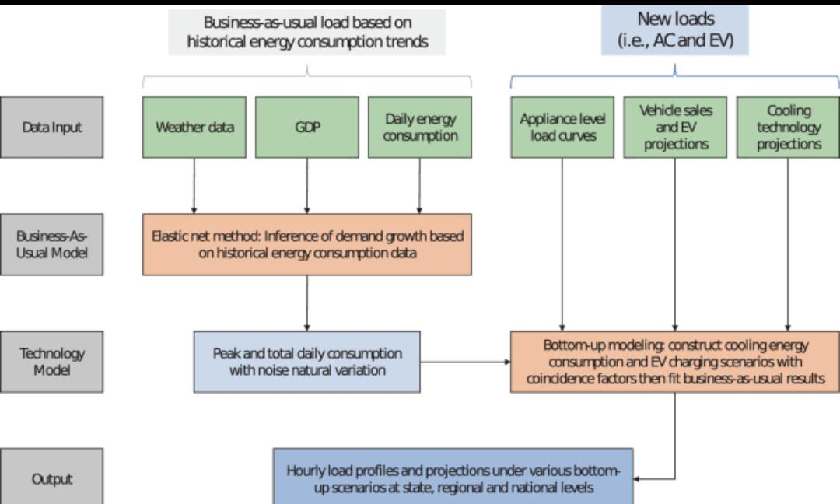

and materials to realize integration, intelligence and systematization in the future. Five research aspects should be focused on: (1) the study on mechanisms of drilling fluid lost circulation and its control to provide basis for scientific selection of lost circulation material formulas, control methods and processes; (2) the research and development of self-adaptive lost circulation materials to improve the matching relationship between lost control materials and fracture scales; (3) the research and development of lost circulation materials with strong retention and strong filling in three-dimensional fracture space, to enhance the retention and filling capacities of materials in fractures and improve the lost circulation control effect; (4) the research and development of lost circulation materials with high temperature tolerance, to ensure the long-term plugging effect of deep high-temperature formations; (5) the study on digital and intelligent lost circulation control technology, to promote the development of lost circulation control technology to digital and intelligent direction.

.

# Contents

### Abstract Contents

**CHAPTER 1 INTRODUCTION**

1.1 Overview

A brief description about project**.**

### CHAPTER 2

### CHAPTER 3

### CHAPTER 5 ADVANTAGES/ APPLICATIONS

* 1. Advantages and Disadvantages.
  2. Applications.

### CHAPTER 6 CONCLUSION & FUTURE SCOPE

* 1. Conclusion summarizing the entire work.
  2. Enhancements that can be made in the future.

## 1.1OVERVIEW

SQL stands for **Structured Query Language**, which is used to interact with Relational Databases. SQL is a **clause-based query language** that can enable extracting large amounts of data within a short period of time. It is an important skill for Data Scientists and Data Analysts, who often query and extract data from databases.

CHAPTER-1

## 1.2INTRODUCTION

* SQL stands for **Structured Query Language** which is used to query, update, and manage **Relational Databases (RDBMS)** and extract data. It is an essential skill for Data Scientists and Analysts as Relational Databases are very common in organizations due to their **simplicity and ease of maintenance**.
* A Relational Database (RDBMS) is a collection of data items with **pre-defined** relationships with them. It organizes data in the form of tables, i.e. in the form 1of rows and columns. In RDBMS, the schema for each feature is pre-defined. A few of the most common Relational Databases are - MySQL, Oracle, etc.
* Relational Databases are managed and interacted with using SQL language. So to extract data from Relational Database(s), you need to **write queries** using SQL statements and clauses.

## 1.3SQL STATEMENTS

One of the main advantages of SQL is its simple syntax and **learning curve**. To **extract data** from RDBMS, you need to write SQL statements which **include _clauses, table names, field names, logical expressions,_** etc. As shown in the below table, there is a basic order for clauses you need to follow while writing SQL statements for data extraction.

## .

|  |  |  |
| --- | --- | --- |
| **Order** | **Clause** | **Description** |
| 1 | SELECT | **SELECT** statement includes data that you want to display. It can include a list of  columns or computed features. |
| 2 | FROM | **FROM** clause indicates the table name which you want to query for data extraction |
| 3 | WHERE | **WHERE** is used to filter data based on a logical expression |
| 4 | GROUP BY | **GROUP BY** clause is used to aggregate data |
| 5 | HAVING | **HAVING** is used to filter aggregated data |
| 6 | ORDER BY | **ORDER BY** clause is used to sort data in ascending or descending order based  on one or multiple columns |
| 7 | LIMIT | **LIMIT** is used to limit the number of rows in the final data |

**CHAPTER-2**

2.1 STORING DATA IN DB

Suppose, if you want to display **student name, their marks, section** when their grade is **A**, you can use below query -

SELECT Name, Marks, Section

FROM student

WHERE Grade = 'A'

The above query will display below table -

|  |  |  |
| --- | --- | --- |
| **Name** | **Section** | **Marks** |
| Chandler | A | 92 |
| Monica | B | 90 |
| Ross | A | 97 |

If you want to display average marks for each section, you can use the **GROUP BY** clause as shown in the below query -

SELECT Section, AVG(Marks) AS AverageMarks

FROM student

GROUP BY Section

Above query will display below table -

|  |  |
| --- | --- |
| **Section** | **AverageMarks** |
| A | 94.5 |
| B | 77.5 |
| C | 80 |

Now, let’s say you want to display section where average marks are **>= 80**. Then you can use the below query -

SELECT Section, AVG(Marks) AS AverageMarks

FROM student

GROUP BY Section

HAVING AverageMarks >= 80

|  |  |
| --- | --- |
| **Section** | **AverageMarks** |
| A | 94.5 |
| C | 80 |

Now, if you want to display the above table in **ascending orders** of average marks, then you can use the below query -

SELECT Section, AVG(Marks) AS AverageMarks

FROM student

GROUP BY Section

HAVING AverageMarks >= 80

ORDER BY AverageMarks ASC

|  |  |
| --- | --- |
| **Section** | **AverageMarks** |
| C | 80 |
| A | 94.5 |

If you want to display the section with **highest average marks**, you can use the query below.

SELECT Section, AVG(Marks) AS AverageMarks

FROM student

GROUP BY Section

HAVING AverageMarks >= 80

ORDER BY AverageMarks DESC

LIMIT 1

|  |  |
| --- | --- |
| **Section** | **AverageMarks** |
| A | 94.5 |

## CHAPTER-3

### 3.1 PERFORM SQL OPERATION

### Using ‘=’ Expression

It is an equal sign which can be used to **filter data** when a column is equal to the **specified value**. Below is one example query for the equal operator -

*-- filter table when section is equal to A*

SELECT Name, Marks, Grade

FROM student

WHERE Section = 'A'

|  |  |  |
| --- | --- | --- |
| **Name** | **Marks** | **Grade** |
| Chandler | 92 | A |
| Ross | 97 | A |

### Using Relational Expressions

Below are the relational expressions which you can use in **WHERE clause** for **data filtering** -

* **> or <**: select rows with **greater or less than** specified value
* **>=**: select rows with **greater than or equal to** specified value
* **<=**: select rows with **less than or equal to** specified value

Let’s have a look at the example mentioned below -

*-- filter table when Marks are greater than or equal to 80*

SELECT Name, Marks, Section, Grade

FROM student

WHERE Marks >= 80

|  |  |  |  |
| --- | --- | --- | --- |
| **Name** | **Section** | **Marks** | **Gr** |
| Chandler | A | 92 | A |
| Monica | B | 90 | A |
| Phoebe | C | 89 | B |
| Ross | A | 97 | A |

### Using Logical Expressions

Below are the logical expressions you can use in the WHERE clause to filter data -

* **AND (&)** - When **two specified conditions** are met
* **OR (|)** - When any of the **two specified conditions** is met
* **NOT** - When a specified condition is **negated**

Let’s have a look at below SQL query to understand how logical expression works -

*-- filter table when either Section is C or Marks are greater than or equal to 90*

SELECT Name, Marks, Section, Grade

FROM student

WHERE (Section = 'C') | (Marks >= 90)

|  |  |  |  |  |
| --- | --- | --- | --- | --- |
| **Name** | **Section** | **Marks** |  | **Grade** |
| Chandler | A | 92 |  | A |
| Monica | B | 90 |  | A |
| Phoebe | C | 89 |  | B |
| Joey | C | 71 |  | C |
| Ross | A | 97 |  | A |

### Using IN Operator

IN operator can be used to filter data when you want to specify a **limited number of options** to match for a column. Below is a query that uses **IN operator** to filter data

*-- filter table when Grade is either A or C*

SELECT Name, Marks, Section, Grade

FROM student

WHERE Grade IN (A, C)

|  |  |  |  |  |
| --- | --- | --- | --- | --- |
| **Name** | **Section** | Marks |  | **Grade** |
| Chandler | A | 92 |  | A |
| Phoebe | C | 89 |  | B |
| Joey | C | 71 |  | C |
| Ross | A | 97 |  | A |

### Using BETWEEN Operator

The **BETWEEN operator** is used when you want to specify a **range in filtering condition**.

*-- filter table when Marks are between 80 and 90*

SELECT Name, Marks, Section, Grade

FROM student

WHERE Marks BETWEEN 80 AND 90

|  |  |  |  |
| --- | --- | --- | --- |
| **Name** | **Section** | **Marks** | **Grade** |
| Monica | B | 90 | A |
| Phoebe | C | 89 | B |
| Joey | C |  | 19 |

## General SQL Conventions

* SQL is **not case sensitive**. So it can be written in lower or upper case letters. However, it is good practice to write SQL clauses such as SELECT, WHERE, FROM, etc. in uppercase letters.
* **Stored data in tables is case-sensitive**. So while using LIKE conditions to match a substring, you must ensure that the specified string is in the required case order.
* You should **avoid spaces in table and column names.**
* SQL ignores white space in code, and no indentation is required while writing SQL queries.
* It is considered a good practice to write comments in your SQL queries.

# CHAPTER 5 ADVANTAGES/ APPLICATIONS

## Advantages and Disadvantages

### Advantages:

1)Data extraction helps recognize which information is most valuable for accomplishing your business objectives, driving the overall ETL process. You can extract useful info concealed within [unstructured](https://www.astera.com/type/infographic/unstructured-data/), [semi-structured](https://www.astera.com/type/blog/structured-semi-structured-and-unstructured-data/) or structured data sources, like customer information.

2)Suppose your business is undergoing decay in profits owing to customer churn. You maintain a record that displays the list of all existing consumers and consumer churn status for every month.

3)To investigate the drift in the churn rate, you’ll have to extract the rows with churn status and aggregate them. This info will help you determine whether or not you can retain your consumers and plan essential strategies (like refining your customer support services) to reduce the turnover rate.

### Disadvantages:

1. **Complex Interface:** SQL has a difficult interface that makes few users uncomfortable while dealing with the database.
2. **Cost:** Some versions are costly and hence, programmers cannot access it.
3. **Partial Control:** Due to hidden business rules, complete control is not given to the database.
4. **Limited Flexibility:** SQL databases are less flexible than NoSQL databases when it comes to handling unstructured or semi-structured data, as they require data to be structured into tables and columns.
5. **Lack of Real-Time Analytics:**SQL databases are designed for batch processing and do not support real-time analytics.

## .

# CHAPTER 5

# CONCLUSION & FUTURE SCOPE

## 5.0CONCLUSION

SQL stands for **Structured Query Language**, and it is used to extract data from Relational Databases quickly.

Its main advantage is its simplified syntax, and you can combine its clauses to write a **complex query**.

Using SQL, you can filter data by specifying multiple conditions, and **pull out data** from

multiple tables.

## 5.1FUTURE SCOPE

1)Living in the 21st century, you might have often come across the word ‘data analytics’. Currently, it is one of the most buzzing terminologies. For those who want to begin their journey in [data analytics](https://www.simplilearn.com/tutorials/data-analytics-tutorial), then this is the right read for you.

2)This blog is your quintessential guide to what is data analytics and will help you understand the subject from scratch. For all you beginners who like playing with data, this is your learning curve for an enriching [career.](https://www.simplilearn.com/tutorials/data-analytics-tutorial/how-to-become-a-data-analyst) Empower your journey with Simplilearn's [Data Analytics Bootcamp](https://www.simplilearn.com/data-analytics-bootcamp). Gain hands-on skills, solve real industry challenges, and excel in the world of Data Analytics.